**Advance Excel Assignment 17**

**1. What are modules in VBA and describe in detail the importance of creating a module?**

**Ans.** In VBA (Visual Basic for Applications), a module is a container that holds a collection of related VBA code. It is a fundamental building block of VBA programming and plays a crucial role in organizing and managing code in Microsoft Office applications such as Excel, Word, and PowerPoint. A module can contain functions, procedures, variables, constants, and other code elements that can be executed by the VBA runtime.  
  
Here are some key aspects and benefits of creating modules in VBA:  
  
1. Code Organization: Modules allow you to logically group and organize your VBA code. You can create separate modules for different tasks or functionalities, making it easier to locate and maintain specific sections of code. This improves code readability, reduces complexity, and enhances code reusability.  
2. Encapsulation: Modules facilitate encapsulation, which is an important principle of object-oriented programming. You can define private variables and procedures within a module that are accessible only within that module. This helps in hiding implementation details and prevents unwanted access or modification of variables and procedures from other parts of the program.  
3. Code Reusability: By placing reusable code in a module, you can easily reuse it across multiple projects or within the same project. You can write generic functions or procedures that perform common tasks and invoke them from different parts of your application. This saves development time, promotes consistency, and reduces code duplication.

**2. What is Class Module and what is the difference between a Class Module and a Module?**

**Ans.** In VBA, a Class Module is a type of module that allows you to define custom objects with their own properties, methods, and events. It is a key feature of object-oriented programming (OOP) and provides a way to create user-defined data types, often referred to as classes. Class modules are available in applications like Excel, Word, Access, and PowerPoint.  
  
Here are the main differences between a Class Module and a standard Module in VBA:  
  
1. Purpose: A standard module is primarily used to store procedures, functions, and variables that are not associated with specific objects. It contains code that can be executed independently or called by other parts of the program. On the other hand, a Class Module is used to define the behavior, properties, and methods of a specific object. It represents a blueprint or template for creating instances of that object.  
2. Object-Oriented Programming: Class modules are an essential component of object-oriented programming, where the emphasis is on modeling real-world objects as classes with their own properties and behaviors. Class modules allow you to define custom objects, create instances of those objects, and interact with them through their properties and methods. Standard modules, on the other hand, do not have this object-oriented capability and are used for general-purpose code organization.  
3. Encapsulation: Class modules provide encapsulation by allowing you to define private variables, properties, and methods that are only accessible within the class itself. This encapsulation helps maintain the integrity of the object's data and behavior by restricting direct access to internal members. In contrast, standard modules do not have this encapsulation feature, and all variables and procedures within a standard module are typically accessible from anywhere in the program.

**3. What are Procedures? What is a Function Procedure and a Property Procedure?**

**Ans.** Procedures in VBA are blocks of code that perform a specific task or set of tasks. They are used to encapsulate a series of instructions that can be executed by the program. VBA supports two types of procedures: Sub procedures (also known as subroutines) and Function procedures.  
  
A Function Procedure and a Property Procedure are two types of procedures in VBA that serve different purposes.  
  
**Function Procedure**: A Function Procedure is a block of code that performs a specific task and returns a value. It is used when you need to calculate or retrieve a value that can be assigned to a variable or used in an expression. Function procedures are commonly used for mathematical calculations, string manipulations, or any task that requires a result.  
Function procedures are defined using the Function keyword followed by a procedure name, optional parameters in parentheses, and a return type specified by the data type or object type. Within the procedure, you must include a Return statement that specifies the value to be returned.

**Property Procedure**:  
A Property Procedure is a special type of procedure used to define the behavior and access of properties within a class module. Properties are attributes of an object that can be read or modified. Property procedures allow you to control how these properties are retrieved or assigned values.

**4. What is a sub procedure and what are all the parts of a sub procedure and when are they used?**

**Ans.**

A Sub Procedure, also known as a subroutine, is a block of code in VBA that performs a specific task or a series of actions. Sub procedures are used when you need to execute a set of instructions without returning a value. They are commonly used for actions like manipulating data, displaying messages, or performing calculations.

In VBA (Visual Basic for Applications), a sub procedure is a block of code that performs a specific task. It is used to organize and modularize code within a VBA macro or module. The parts of a sub procedure in VBA are as follows:  
  
Sub Procedure Name: This is the identifier that uniquely names the sub procedure. It should follow VBA naming conventions and be descriptive of the task it performs.  
Optional Parameters: Sub procedures can have optional parameters that allow you to pass values or objects to the subroutine. These parameters are enclosed in parentheses after the procedure name. They can be used to provide input or additional information required for the subroutine's execution.  
Variable Declarations: Inside the sub procedure, you can declare variables using the Dim statement. Variables are used to store data or temporary values needed for calculations within the subroutine.

**5. How do you add comments in a VBA code? How do you add multiple lines of comments in a VBA code?**

**Ans.**

1. First, **click on the line** where you want to insert the comment.
2. After that, **type an APOSTROPHE** using your keyboard key.
3. Next, **type the comment** that you want to add to the code.
4. In the end, **hit enter** to move to the new line and the comment will turn green.

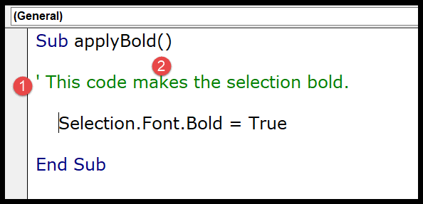

The moment you do this the entire line of the code will turn green which means that line is comment now.

If you look at the below code where I have used a comment to add a description of the procedure.

So you simply need to add an apostrophe before turning it into a comment and VBA will ignore it while executing the code.